Introduction
School uniform is an important part of the ethos of Shenley Brook End school and all students are encouraged to always take pride in their appearance and their association with the school. School uniform should be worn to and from school as well as during the school day.
School uniform can be purchased from Kedaph Schoolwear, Unit A Lennox Road, Bletchley, Milton Keynes, MK2 2HH
Kedaph Schoolwear – Milton Keynes – Your Best School Supplies
All items specified as ‘Shenley Brook End School approved’ sold by Kedaph satisfy our requirements. Selected items can be bought from other retailers e.g. John Lewis, M&S and Tesco but must conform to the uniform guidance. Please be aware that some shops sell items as ‘school wear’ that do not fulfil our requirements.
Year 11 will still be required to wear the SBE blazer if they choose not to switch to the embroidered jumpers.
The Jumper Design
The jumpers identify the student’s year group and house. The jumper has the appropriate year group colour displayed around the V-neck section of the jumper, with the school logo embroidered onto the right-hand side of the jumper. The house colouring goes around the outside of the school logo on the jumper.
The jumper’s material will be 100% acrylic and long lasting. The jumpers should be able to be passed down to other students through pre-loved uniform or to siblings but as they have the year groups this will be on a 5-year cycle.
PE Kit on PE Days
Students are permitted to wear PE kit into school on days where they have a PE lesson. This removes students needing to come into school in uniform and then getting changed before and after PE lessons. Please see below further information regarding PE kit.
Year Group and House Colours
The year group colours from September 2025 are as follows:
Year 7 – Purple
Year 8 – Blue
Year 9 – Green
Year 10 – Yellow
Year 11 – Red
The house colours are as follows:
Sycamore – Orange
Birch – Blue
Elm – Yellow
Hawthorn – Green
Chestnut – Purple







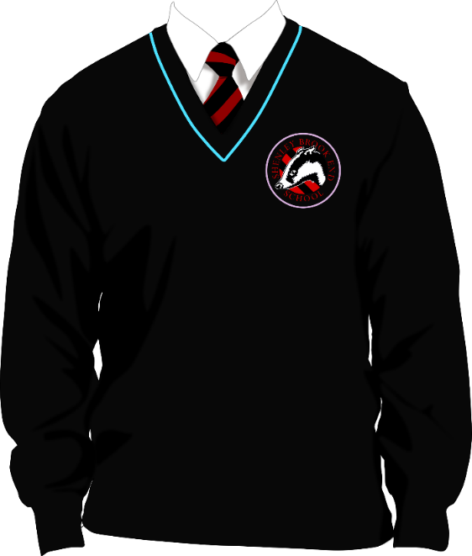

As shown in the jumper design here, this student’s year group colour is blue and their house colour is purple.

This jumper has a year group V-neck colour of green and house colour around the school logo of orange so will be for a Year 8 student in Sycamore house
This jumper has a year group V-neck colour of yellow and house colour around the school logo of blue so will be for a Year 9 student in Birch house.
This jumper has a year group V-neck colour of blue and house colour around the school logo of purple so will be for a Year 7 student in Chestnut house.

Costing
The price of the jumpers, for all sizes, can be found below. These prices have been confirmed with Kedaph, our uniform supplier.
Size 30 - 34 : £22.99
Size 36 - 40 : £24.99
Size 42 - 46 : £26.99
Below is a breakdown of the approximate price of a full set of school uniform per child.

uniform item | branded? | cost per item (£) | number of items per pupil | Total cost (£)
Jumper | Yes | £26 | 1 | £26
Shirt | No | £5.50 | 2 | £11
Tie | Yes | £7 | 1 | £7
Shoes | No | £35 | 1 | £35
Skirt/Trousers | No | £10 | 2 | £20
Total Cost = |  |  |  | £99
The costing table is based off of a Year 11 student, with the biggest sizes available, therefore the pricing can be lower for younger students and cheaper for families to pay for. With students being able to wear PE kit on PE days (which will be a minimum of five days over the two-week timetable), parents may look more towards purchasing one jumper, rather than two.
Uniform Item List
Students in Year 7, 8, 9 and 10 will be required to wear the following uniform:
Embroidered Shenley Brook End School jumper | Must be worn at all times around the school building. Teachers choice in lesson, depending on the weather/temperature.
Shirt | Must be fastened at the neck and polo shirts are not allowed.
Tie | Must fall to more than half of the shirt.
Skirt/Trousers | No stretch skirts and must be knee length. No stretch trousers, leggings, chinos or denim.
Shoes | Plain black in colour. Formal ankle boots that go no higher than the ankle are allowed.
Black socks | Socks no higher than the knee. No colours other than black
Tights | Plain tights with no patterns

Students in Year 11 will be required to wear the following uniform. Students in Year 11 can opt to wear the jumper, but if not, they will need to wear the Shenley Brook End blazer.

Blazer | Must be worn at all times around the school building. Teachers choice in lesson, depending on the weather/temperature.
Optional plain v-neck jumper
Shirt | Must be fastened at the neck and polo shirts are not allowed.
Tie | Must fall to more than half of the shirt.
Skirt/Trousers | No stretch skirts and must be knee length. No stretch trousers, leggings, chinos or denim.
Shoes | Plain black in colour. Formal ankle boots that go no higher than the ankle are allowed.
Black socks | Socks no higher than the knee. No colours other than black
Tights | Plain tights with no patterns

PE Kit
In addition to uniform PE kit needs to be purchased for Shenley Brook End students. The PE kit policy has been adapted and made more affordable for parents. There are now less branded items that are compulsory for students to have for their PE lessons. The following items are for PE, with the costings included:

uniform item | branded? | cost per item (£) | number of items per pupil | Total cost (£)
PE Top | Yes | £16 | 1 | £16
PE Hoodie (optional) | Yes | £21 | 1 | £21
Plain Black Bottoms (leggings, tracksuit bottoms or shorts) | No | £6 | 1 | £6
Trainers | No | Approximately £35 | 1 | £35
Studded Boots | No | Approximately £20 | 1 | £20
Total Cost = |  |  |  | £98

Students can wear PE kit into school on days where they have PE lessons.
Shorts that are worn for PE lessons need to be a minimum mid-thigh length. Cycling shorts or skin tight shorts cannot be worn. Shorts also need to be presented in full form and should not be tucked or rolled up. Sports leggings, worn with PE kit, must be thick enough to ensure they are not see through when worn or stretched. In cold and wet weather, normal school coats / jackets can be worn over this. Sensible hats and gloves are permitted also. This does not apply to after-school PE clubs or fixtures – students involved in those activities will still need to bring their kit and change as usual.
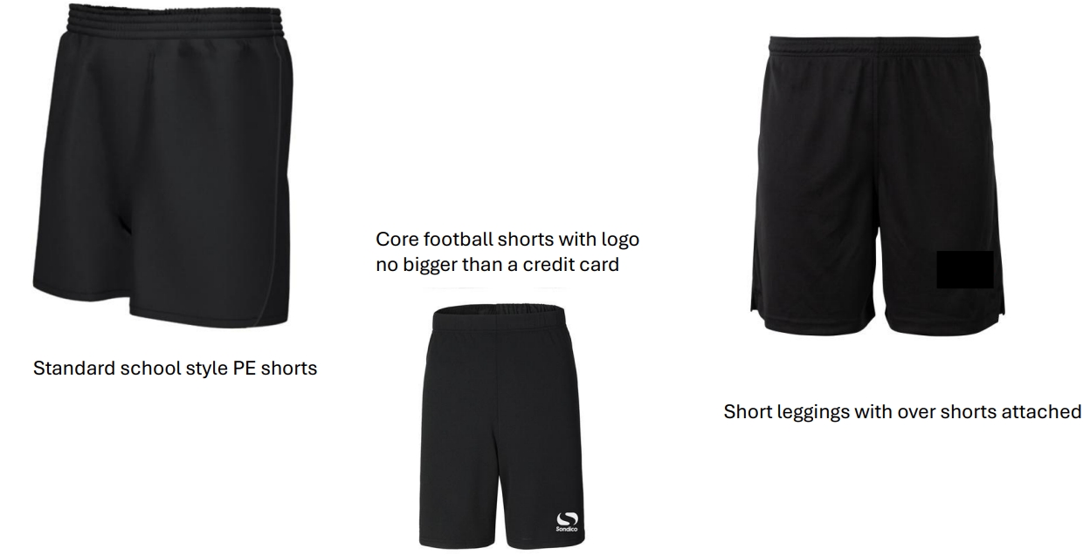
Examples of shorts

PE Uniform | Other Information
Shenley Brook End red PE sports polo shirt
Shenley Brook End red PE hoodie (optional) | Can be worn during cold or wet weather.
Plain black tracksuit bottoms, joggers or sports style thick leggings | No brands or logo size must be less than a credit card size with no fashion stripes. Leggings must be thick sports style not standard leisurewear so thick enough to not be see through when worn or stretched
Plain black PE shorts - minimum mid-thigh length. | Cycling or skin-tight shorts cannot be worn. Shorts need to be presented in full form and not tucked or rolled up.
Trainers – No colour requirements but must be non-marking | Crocs and sliders are not appropriate. Recommended that trainers are not of high value.
Football Boots – moulded studs only | Expensive boots are not required.
Sports socks – plain white, plain white ankle or knee length red football style socks | If wearing shin pads for sport, then knee length socks are required.
Base layers (optional) – plain red or black only | Base layers/skins can be worn underneath the approved PE kit.

Frequently Asked Questions
Why do we have a school uniform?
Uniform is important to a school as it creates a sense of community, gives students a sense of belonging and creates an identity for our school within our local community. Students, parents and staff acknowledge it should be a proud thing to wear a school uniform, as well as creating a school ethos. If students are getting uniform right, then it also contributes towards good behaviour and discipline in school.

Does wearing a uniform help reduce bullying?
From our staff, parent/carer and student surveys all stakeholders realised that wearing a uniform reduces the likelihood of bullying taking place, as there is no variance in student clothing.

What happens if my child forgets to bring/wear their tie to school?
We have some spare ties that are in the pastoral offices. Students can trade their phone with a tie for the day, to avoid receiving a uniform mark. We ask for the student’s phone for the day within the trade so that we get the tie back and can continue offering this to students.

What is extreme uniform?
Extreme uniform includes the following items:
- Tracksuit bottoms worn with school uniform
- Leggings worn with school uniform
- Cycling shorts
- PE kit on a non-PE day (this includes variations too eg plain black top and PE kit bottoms on a non-PE day)
- Crocs
- Ugg boots
What happens if a student comes into school in extreme uniform?
If a student comes into school wearing an item on the extreme uniform list, as noted above, they will be brought down to the removal room. If we have an item of uniform that the student is missing, that can correct their extreme uniform, from our spare uniform storage, this will be offered in the first instance. If this is not possible, or students refuse, then contact home is made and students stay working in the removal room, out of circulation, until the correct uniform can be brought in from home to rectify the situation.

